YOUTH LEADERSHIP PROGRAM APPLICATION
PROGRAM OVERVIEW: Youth Leadership for the YVPC-Denver Media program is a program of Leadership from both the Montbello and Parkhill Communities. It is offered to a diverse group of high school seniors and college students who have leadership potential. The program will help to develop basic skills in leadership, graphic design, problem-solving and communication while gaining awareness of community issues, diversity, and personal potential.
Selection will be made by a committee of community representatives and college alumni. All applicants will receive notification of their selection by Friday, October 11,2019.
Requirements:
Applicants must be a senior in high school or a college student.
Applicants must live, work, play in either in the Montbello or Parkhill Communities
Applicants should have a strong interest in helping develop a media campaign.
Applicants must abide by the program attendance policy apart from excused absences.
Recommendation Letter:
Please include a letter of recommendation.
This letter should tell how long and in what capacity the reference has known you, what contributions you would bring to the YVPC- Denver Youth Leadership experience, how you might benefit from the experience and anything else that would give the committee a more complete picture of you.

Reference Form:
In addition to the above letter of recommendation please have someone in the community complete the attached reference form. This form should be included with your application. The reference form should be filled out by someone different from the person writing the recommendation letter.

Application Process:
- Applications must be RECEIVED in either the Montbello / or Parkhill Office no later than 5:00pm on Thursday, October 17, 2019. All applications can be submitted by mail or hand delivered to one of our office locations. Emailed applications will be accepted as well.
- One letter of recommendation is required.
- Applications should be legible or typed to be seriously considered.
- YVPC- Denver will select 1 youth per community.

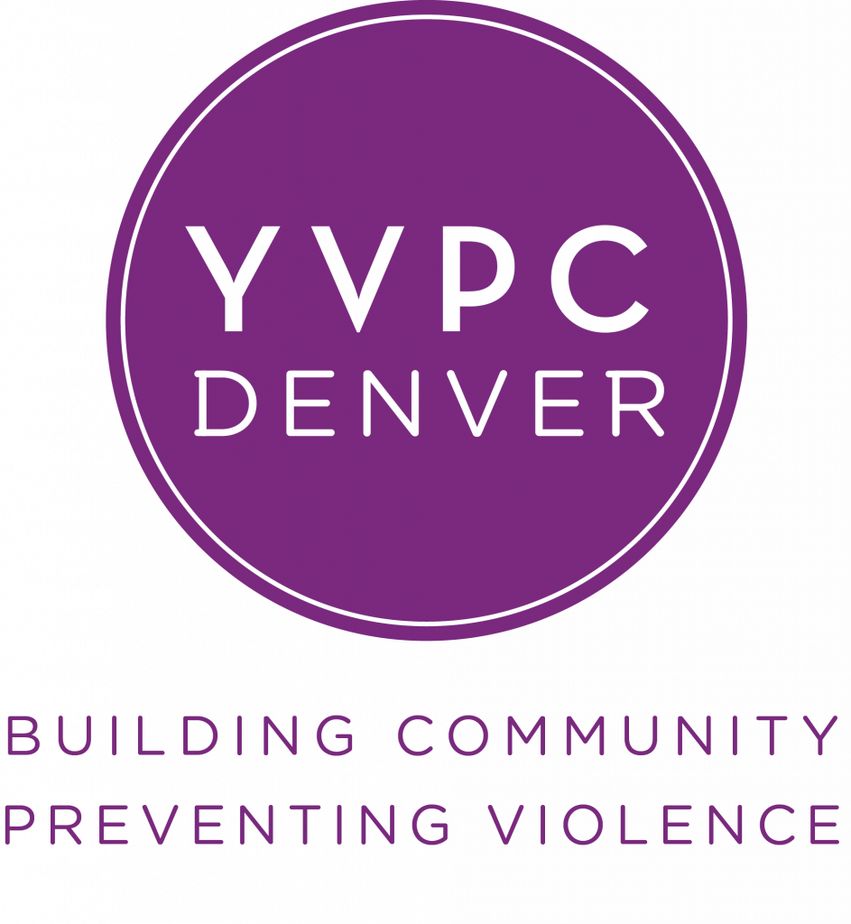
Please carefully read the application process instructions on page one before completing the application.

Applicant Name
Last First Middle Initial Preferred Name

Mailing Address
Address City State Zip Code

Cell Phone ( ) Applicant Email ________________

Parent/Guardian Cell Phone ( )

Parent/Guardian Email ___________________________

High School/ College Attended Name __________________________________________
Optional Information: YVPC- Denver (Steps to Success / Park Hill Strong) does not discriminate based on race, ethnicity, sex, creed, national origin or disability. This information is not required. It is requested to facilitate our goal of assembling a diverse class.

Gender: Female Male

Race/Ethnicity: American Indian Asian African American
Hispanic White Other: _________

Experience: Photoshop Adobe Illustrator Gimp
Canva Inkscape Other: _________
Public Speaking
Facilitating Groups

What does a media campaign about youth violence prevention look like to you?

_________________________________________________________________________________________________

________________________________________________________________________________________________________________________________________________________________________________________________________________
________________________________________________________________________________________________________

Please let us know the leadership roles you have held while involved in organizations or activities both in your school and/or community. These should be in order of importance, listing up to five school, social, athletic, religious, community service, or other activities and organizations in which you have participated during the last year.

1.
2.
3.
4.
5.

List any community service or volunteer work experience and briefly tell what was involved.
______

List any work experience in which you were compensated for and briefly tell what was involved.

What do you consider to be one of your strengths?

What do you consider to be one of your weaknesses?

If you could change anything about the perception of Youth Violence in the Montbello or Parkhill communities, what would it be and why?

Why are you applying for Youth Leadership for YVPC- Denver? __________________________________________________________

What are you hoping to gain from being a part of Youth Leadership for YVPC- Denver? _____________________________________

YVPC-Denver Youth Leadership
Code of Responsibility

Statement of Purpose

The purpose of the YVPC- Denver Youth Leadership through Steps to Success Montbello/ or Park Hill Strong is to prepare youth to make a positive difference. Participants are selected because of their proven leadership qualities. The actions of program participants reflect on Leadership of the University of Colorado Boulder and affect the results the program is intended to achieve.

Participation in the YVPC- Denver Youth Leadership carries the responsibility of leadership. Participants are expected to observe the highest standards of behavior and to set an example for others to follow.

This Code of Responsibility is intended to describe minimum acceptable standards and the consequences of failure to meet these standards. Those who fail to observe these standards can be held accountable for their actions.

Applicability

This Code is applicable to all participants in the YVPC- Denver Youth Leadership including youth leader, ambassadors, media team, adult facilitators and staff. This Code is always applicable.

YVPC- Denver Youth Leadership through Steps to Success Montbello/ or Park Hill Strong seeks to encourage personal growth and development of the skills and behavior required of good leaders.

By participating in YVPC- Denver Youth Leadership through Steps to Success Montbello/ or Park Hill Strong, all participants acknowledge that their actions are subject to this code.

Policy on Attendance
YVPC- Denver Youth Leadership is an integrated series of experiences designed to be completed with a consistent group of youth. Attendance and participation at all scheduled events is necessary to obtain the full benefits of the program.

Discipline
Appropriate behavior is expected of all participants.

I, , (Participant) certify that I have read and understand the Policies of YVPC- Denver Youth Leadership in the Code of Responsibility and that I will abide by these Policies.

_____________________________ ______________________________
Signature of Participant Signature of Parent/Guardian

_____________________________ ____________________________
Date Date

YVPC- Denver Youth Leadership
Commitment Form

This form must be signed by all parties as indicated and returned with the application.

Applicant Name (please print)

I understand that as a youth who is accepted to the YVPC- Denver Youth Leadership program is given a space in the program that is then not available to other applicants. Consequently, youth who apply for the program SHOULD intend to participate fully in the YVPC- Denver Youth Leadership program.

_____________________________ ______________________________
Applicant Date

_____________________________ ______________________________
Applicant’s Parent/Guardian Date

YVPC- DENVER YOUTH LEADERSHIP REFERENCE FORM
DEADLINE –

This Reference Form is to be submitted with your application
RECOMMENDATION FOR ________________________________
TO THE APPLICANT: Please type/print in the space above and give this form to this person completing your reference.
TO THE REFERENT: The applicant above will be considered for a 12-week Youth Leadership opportunity if selected. This program is designed to provide emerging leaders an opportunity to develop a hope, pride and engagement of youth violence prevention programming to two communities (Montbello and Parkhill). The program will include mentoring, youth development, hands on opportunities and community experiences designed to increase knowledge, enhance skills and experience around community engagement and youth violence prevention.
As we are seeking the most outstanding youth from the far northeast communities, it is important for each applicant’s referral to provide the YVPC -Denver selection committee with an assessment of the youth using the form below. Thank you in advance for taking the time to respond in the most direct and forthcoming manner possible.
How long have you known the above applicant and what has been your relationship?
Please assess the applicant using these criteria: 5-Excellent; 4-Good; 3-Satisfactory; 2-Poor; 1-Not Acceptable.

___ A) LEADERSHIP INTEGRITY: The degree to which the applicant is recognized and respected by peers, teachers and community. Includes personal integrity, character and reputation in both personal and school contacts.
___ B) NETWORKING/TEAMWORK EFFECTIVENESS: Demonstrated success as a leader working with others to get things done.
___ C) ANALYTICAL / PROBLEM SOLVING SKILLS: Mental ability to understand complex issues. Includes depth of insight and desire to seek solutions of issues facing far northeast communities.
___ D) COMMUNICATION SKILLS: Includes writing, speaking, listening, and willingness to interact with individuals and groups.
___ E) POTENTIAL FOR GROWTH: Open to broadening experiences and contacts, especially with those of different cultures or viewpoints.
___ F) DEPENDABILITY/CONSISTENCY: Commitment to following through on tasks undertaken.
___ G) ASSESSMENT OF CURRENT LEADERSHIP EFFECTIVENESS: Extent to which currently involved and successful
in leadership activities.

___ H) ASSESSMENT OF LEADERSHIP POTENTIAL: Desire for and commitment to future involvement in leadership positions.

In addition to the above responses, we request additional comments that you might share regarding this individual.
____________________________________________________________________________________________________________________________________________________________________________________________________________________________________________________________________________________________________________________________________________________________________________________________________________________________________________________________________________________________________________________________________________________________________________________________________________________________________________________________________________________________________________

Referent’s Name (please print) ____________________________________
Title ____________________________________________

Referent’s Signature____________________________________________
Date ____________________________________________

